SAMPLE QUESTIONS FROM PAST STUDENT WORK

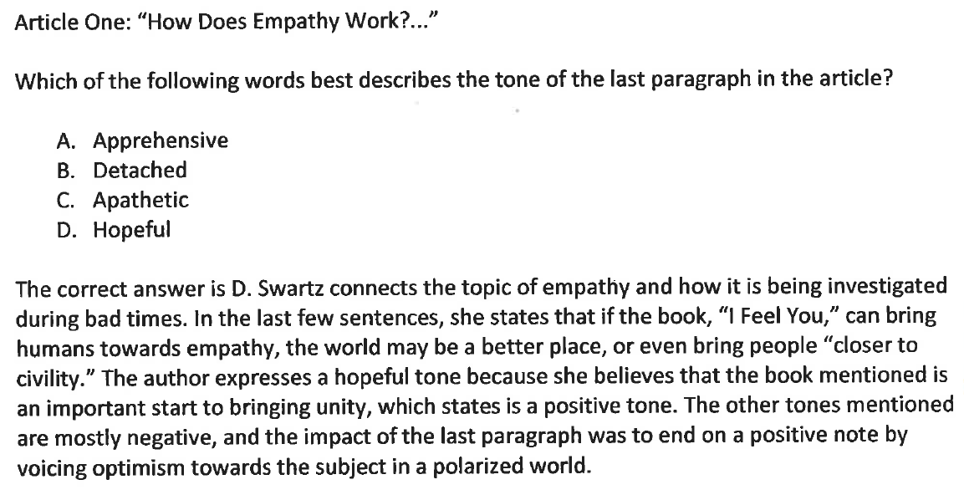

WHY IS THIS AN “A”-LEVEL QUESTION?
- The answer choices are believable (for instance, student did not include a silly choice, like “crusty”).
- The student quotes a snippet (a little excerpt) of the article to support the right answer.
- The author references the positive/negative tone technique practiced in class to help explain the right answer.

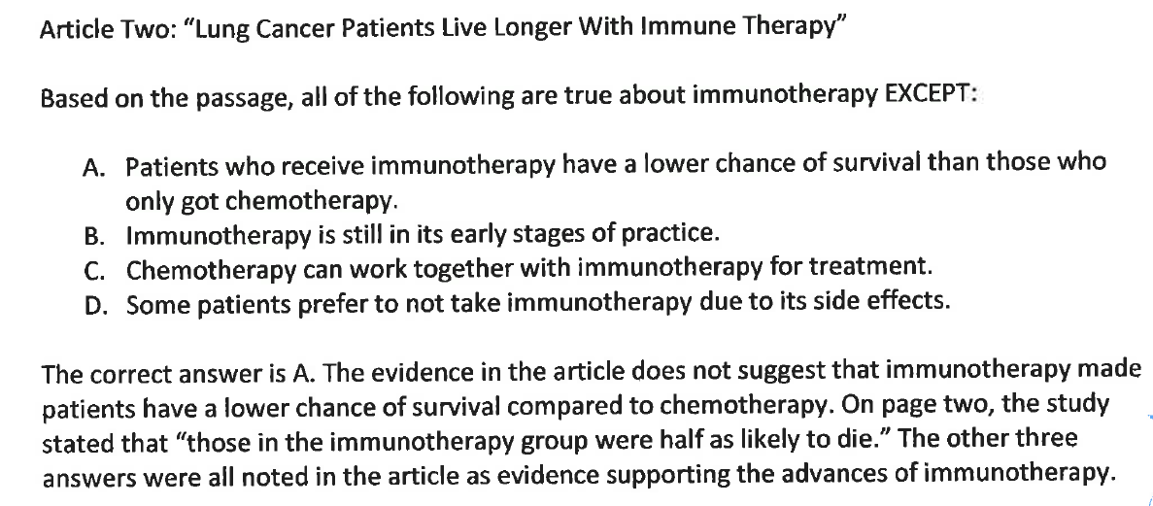

WHY IS THIS AN “A”-LEVEL QUESTION?
- The answer choices are believable.
- The student quotes a snippet (a little excerpt) of the article to support the right answer.
- The student briefly addresses why the other choices are incorrect.

